Project Overview Document
R.E.D. Model: Insider Threat Detection AI System
Recognize. Execute with purpose. Defend.
“We recognize threats, execute with purpose, and defend what matters.”

Overview
The R.E.D. (Recognize. Execute with purpose. Defend.) Insider Threat Detection AI Model is a Python-based solution designed to identify and mitigate insider threats within organizations. By leveraging behavioral data, contextual activity logs, and risk indicators, the model assesses insider risks through a combination of rule-based and machine learning (ML) techniques. It generates a comprehensive risk profile for each employee or user, enabling security teams to take proactive, informed actions to protect digital ecosystems.
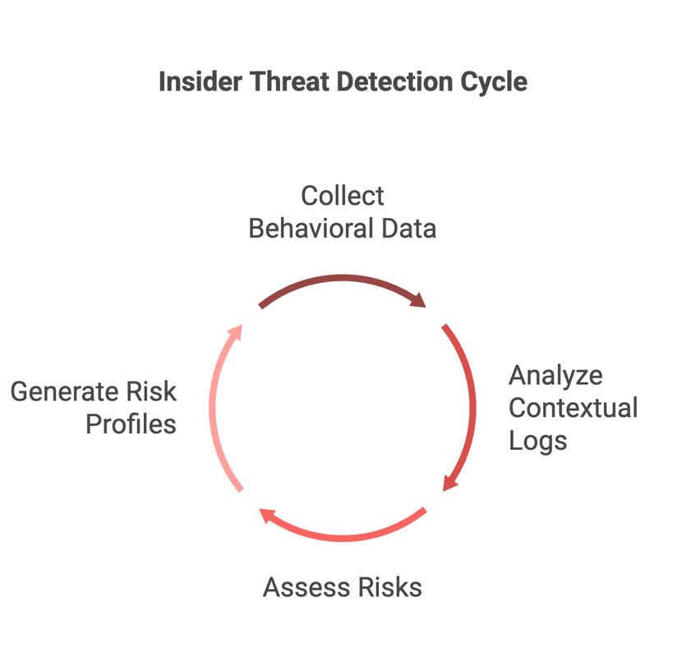
Vision
Recognize cybersecurity threats through intelligent, ethical, and proactive detection strategies.
Mission
Execute a lightweight yet powerful insider threat detection engine that integrates seamlessly into real-world environments and defends organizational assets.
Purpose
To provide organizations with an actionable, interpretable, and adaptive framework to assess and respond to insider risks—from negligent behaviors to malicious intent.

Key Features
- Scalable Processing: Handles large datasets through chunked processing using openpyxl.
- Dual Detection Approach: Combines rule-based scoring with an optional logistic regression ML model.
- Comprehensive Risk Profiling: Assesses risks across five categories: Information Disclosure, Unauthorized Data Operations, Credential Abuse, Security Evasion and Bypass, and Software and Code Manipulation.
- Actionable Outputs: Generates a color-coded XLSX report with detailed risk scores, mitigation recommendations, and a summary sheet.
- Visual Insights: Includes a risk score distribution histogram for quick analysis.
- Customizable Configuration: Allows users to define approved apps, IPs, devices, and more via a config.json file.
- NIST-Aligned Mitigation: Provides recommendations mapped to the NIST Cybersecurity Framework and 8 industry best-practice strategies.
- Robust Validation: Ensures mandatory fields like Employee_ID are present, dropping invalid rows with appropriate logging.
Input Features (Excel/CSV Format)
The R.E.D. Model expects input data in XLSX or CSV format with the following 17 columns:
- Employee_ID: Unique identifier for the employee (mandatory, non-empty).
- Access_Level: Access privilege level (1–5, where 5 is highest).
- Login_Hours: Average daily hours on sensitive systems (0–24).
- Data_Transfers: Number of large data movements (e.g., downloads, uploads).
- Phishing_Training_Score: Employee’s phishing training score (0–100).
- Disengagement_Score: HR-calculated disengagement score (0–10).
- Vendor_Access: Binary flag (1 if vendor, 0 if internal employee).
- Anomaly_Score: Anomaly detection score (0–10, higher indicates more unusual behavior).
- Timestamp: Date and time of the activity (e.g., “2025-04-01 02:00:00”).
- Resource_Accessed: Resource accessed (e.g., “Battery_Designs”).
- Action_Taken: Action performed (e.g., “Download”, “View”, “Modify”).
- Location/IP: IP address or location of the activity (e.g., “192.168.1.1”).
- Login_Method: Method of login (e.g., “Password”, “SSO”).
- Device_Used: Device used (e.g., “Work Laptop”, “USB”).
- Clipboard_Accessed: Whether clipboard was accessed (e.g., “Yes”, “No”).
- Application_Used: Application used (e.g., “Excel”, “Dropbox”).
- Session_Duration: Duration of the session in minutes (e.g., 120).

Risk Detection & Analysis Logic
Rule-Based Detection
- 5 Risk Categories:
  - Information Disclosure: Risks related to data leaks (e.g., high data transfers, clipboard access).
  - Unauthorized Data Operations: Unauthorized actions on sensitive resources (e.g., long session durations).
  - Credential Abuse: Misuse of access privileges (e.g., high access level, low phishing training score).
  - Security Evasion and Bypass: Attempts to bypass security (e.g., off-hours logins, unfamiliar IPs).
  - Software and Code Manipulation: Use of unapproved applications (e.g., Dropbox instead of approved apps).
- Risk Level: Categorized as Low (0–29), Medium (30–49), High (50–69), or Critical (70–100).
- Auto Alert Generation: Triggers alerts based on severity, correlation triggers (e.g., off-hours + unfamiliar IP), and behavioral red flags (e.g., high disengagement score).
- Mitigation Recommendation: Provides NIST-aligned recommendations (e.g., “Implement MFA”) mapped to 8 mitigation strategies (e.g., Strategy 1: Conduct Phishing Training).
ML-Based Scoring
- Model: Logistic regression with smart features:
  - Interaction Term: Access_Level × Data_Transfers to capture combined risk.
  - Binary Risk Signals: Off-hours logins, unfamiliar IPs, unapproved devices, etc.
- Output: ML Risk Score (0–100) to supplement rule-based scoring (enabled via config.json).
Output (Excel Format)
The R.E.D. Model generates an XLSX report with two sheets:
- Risk Assessment Sheet:
  - Employee_ID: Unique identifier.
  - Risk_Score: Rule-based risk score (0–100).
  - Risk_Level: Low, Medium, High, or Critical (color-coded).
  - Detected_Attack_Vector: Primary risk category (e.g., “Info Disclosure”).
  - Trigger_Reason: Reasons for the risk score (e.g., “High Access Level, Off-Hours Login”).
  - Auto_Alert: Whether an alert was triggered (Yes/No).
  - Mitigation_Recommended: Actionable recommendations (e.g., “Implement MFA”).
  - Anomaly_Score: Anomaly detection score (0–10).
  - Timestamp: Date and time of the activity.
  - Session_Details: Summary of the session (e.g., “Action: Download, Resource: Battery_Designs, IP: 192.168.1.2, Device: USB”).
  - ML_Risk_Score: ML-based risk score (0–100, if enabled).
- Summary Sheet:
  - Total employees, risk distribution (Low/Medium/High/Critical), most common attack vector, number of auto-alerts, and average ML risk score (if enabled).
- Visualization: A risk_score_distribution.png file showing a histogram of rule-based risk scores.
Future Enhancements
- Real-time stream processing (Kafka/event-based logs).
- Web dashboard integration (Flask/Dash).
- Behavioral baseline learning per employee.
- Email alerts to SOC teams on critical risks.
- Integration with DLP/EDR solutions.
- Audit log replayer for forensic investigation.
- Tuning via feedback loop (analyst labeling).
Real-World Use Cases
- Detect disgruntled employees leaking product prototypes.
- Flag off-hours downloads from vendors.
- Auto-alert on clipboard access during remote sessions.
- Score disengaged staff with high resource usage.
- Visualize insider risk across business units.
Alignment
- NIST Cybersecurity Framework: Aligns with Identify, Protect, Detect, Respond, and Recover phases.
- 8 Industry Best-Practice Strategies for Insider Threat Mitigation: Maps recommendations to strategies like phishing training, MFA implementation, and DLP tools.
Benefits
- Proactive Detection: Identifies risks before they escalate into breaches.
- Actionable Insights: Provides clear mitigation recommendations for security teams.
- Scalability: Processes large datasets efficiently with chunked processing.
- User-Friendly Output: Color-coded reports and visualizations for quick analysis.
- Compliance Support: Aligns with NIST and industry standards for insider threat mitigation.

System Architecture of Data Flow:
